Segmentation Model, Inference on ROI
ROI:
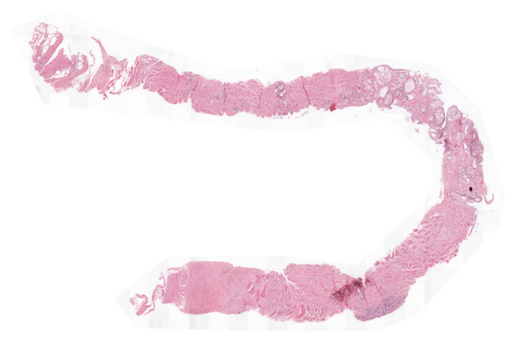
Width = 1010, height = 668
Model Input Patch Size = 512

Inference using Fully Connected Net
- Pad the image:
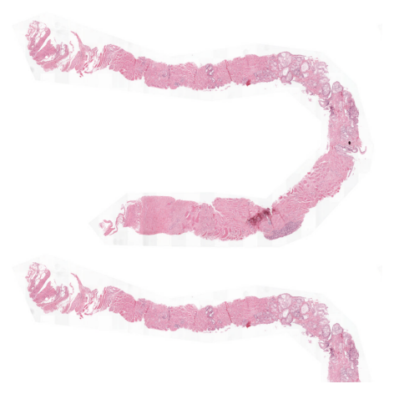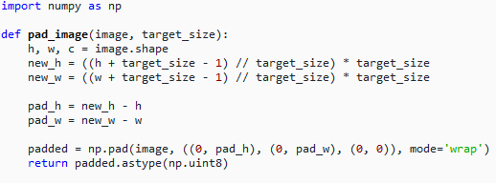
Width = height = 1024 (mode = Wrap)
- Passing the padded image to the model (model output, logits):
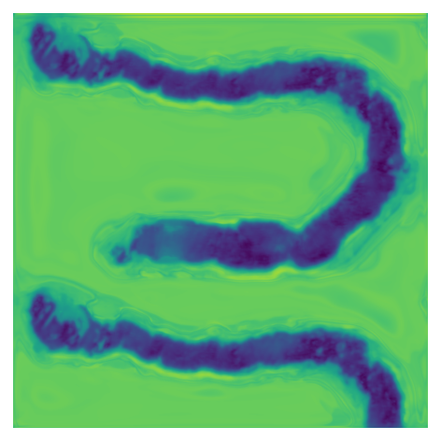
- Cropping the padded image output to the original image size:
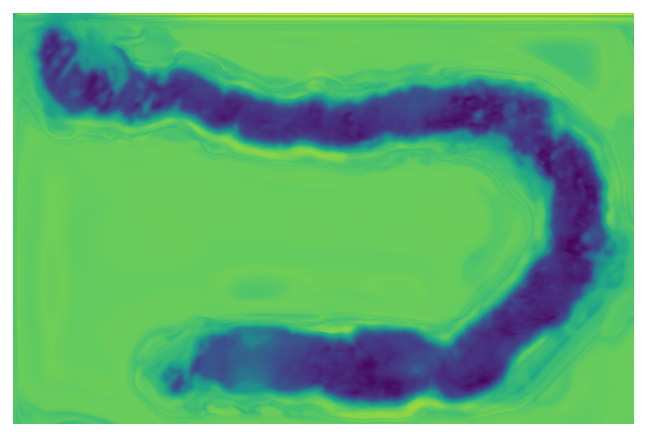
- Applying argmax to obtain the class prediction:
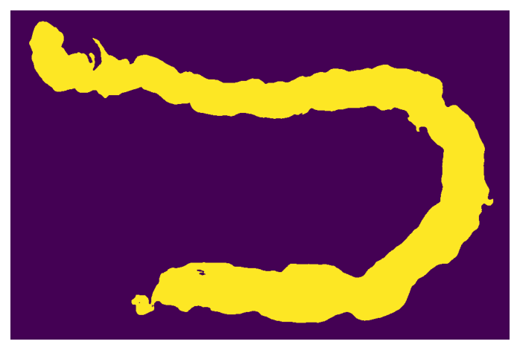

Inference using Sliding Window
- Pad the image, same as before.
- Extracting patches of size 512 with stride of 256 using the sliding window technique:
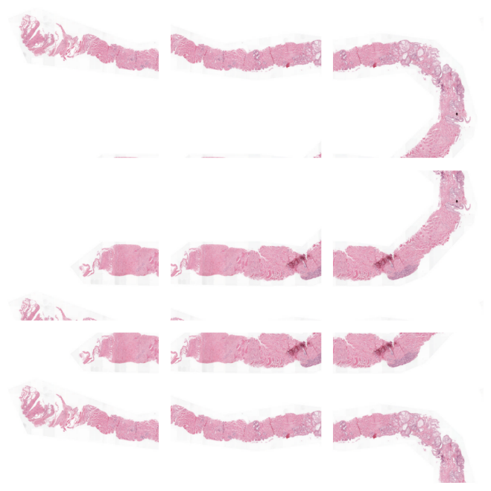
- Passing the extracted patches to the model (model output, logits):
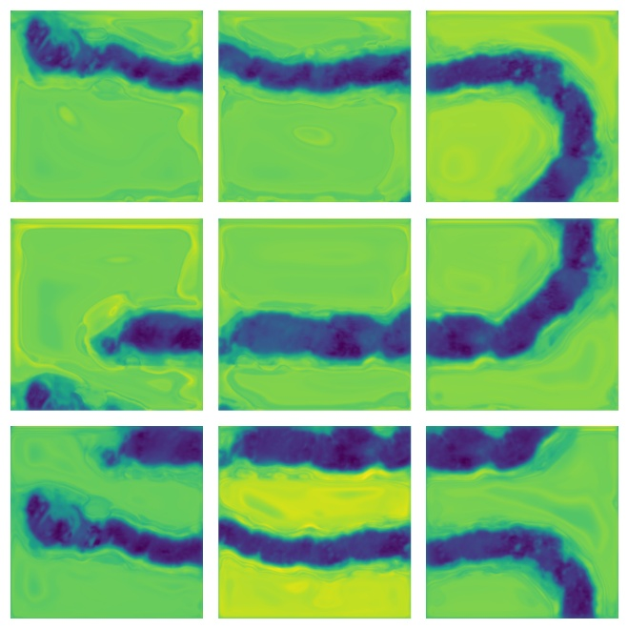
- After running the sliding-window inference, each window produces a logits tensor of shape (C, 512, 512), where C is the number of classes. Because the stride is 256, adjacent windows overlap by 50%, which means many pixels are predicted multiple times. To reconstruct the full-resolution segmentation map, we need to merge these overlapping predictions. The stitching process works as follows:
- Initialize an empty logits canvas: Create an array of the size of the padded image, shaped (C, H, W), along with a counter map to track how many times each pixel has been covered.
- Accumulate logits from each patch: For every sliding window position, place its logits into the corresponding location in the canvas.
- In overlapped regions, logits from multiple patches are summed (or averaged later), ensuring all predictions contribute.
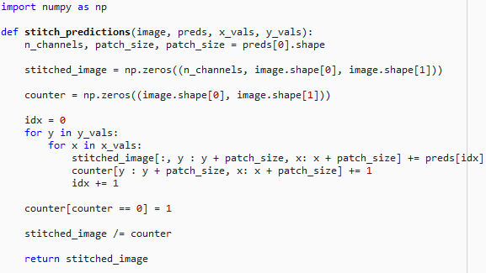
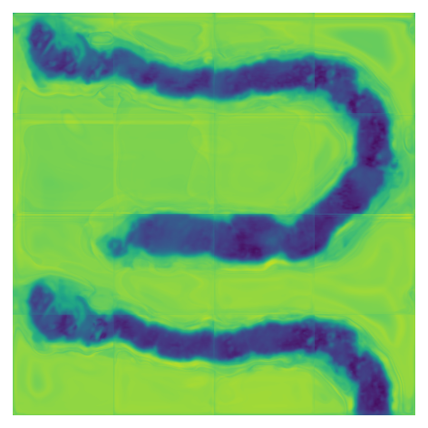
- Cropping the padded image output to the original image size:
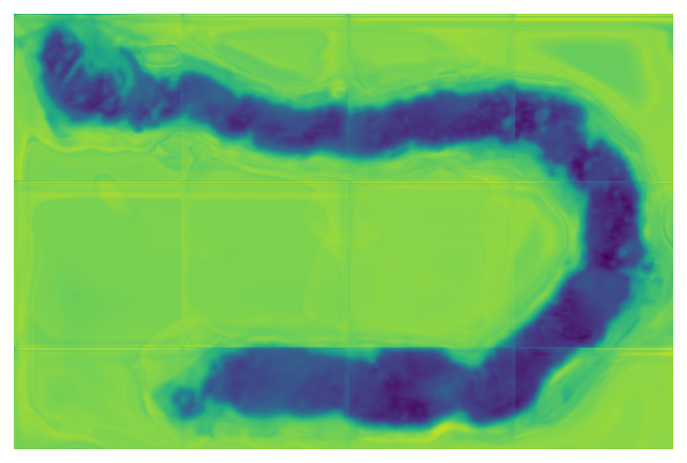
- Applying argmax to obtain the class prediction:
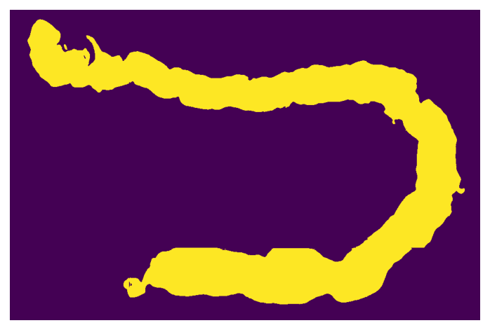

Inference using Center Crop
- Pad the image, same as before.
- Pad the image again for center crop approach, adds half of the input patch size on both sides of padded image:
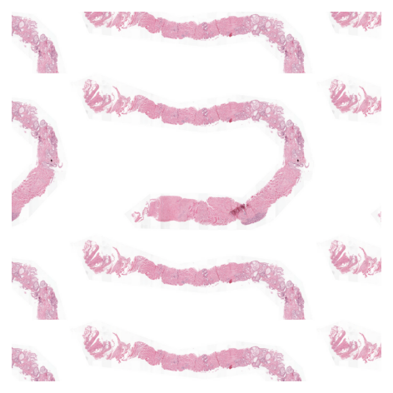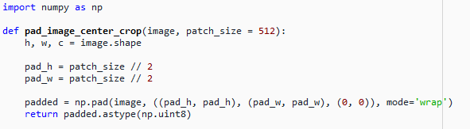
- Extracting patches of size 512 with stride of 256 using the sliding window technique:
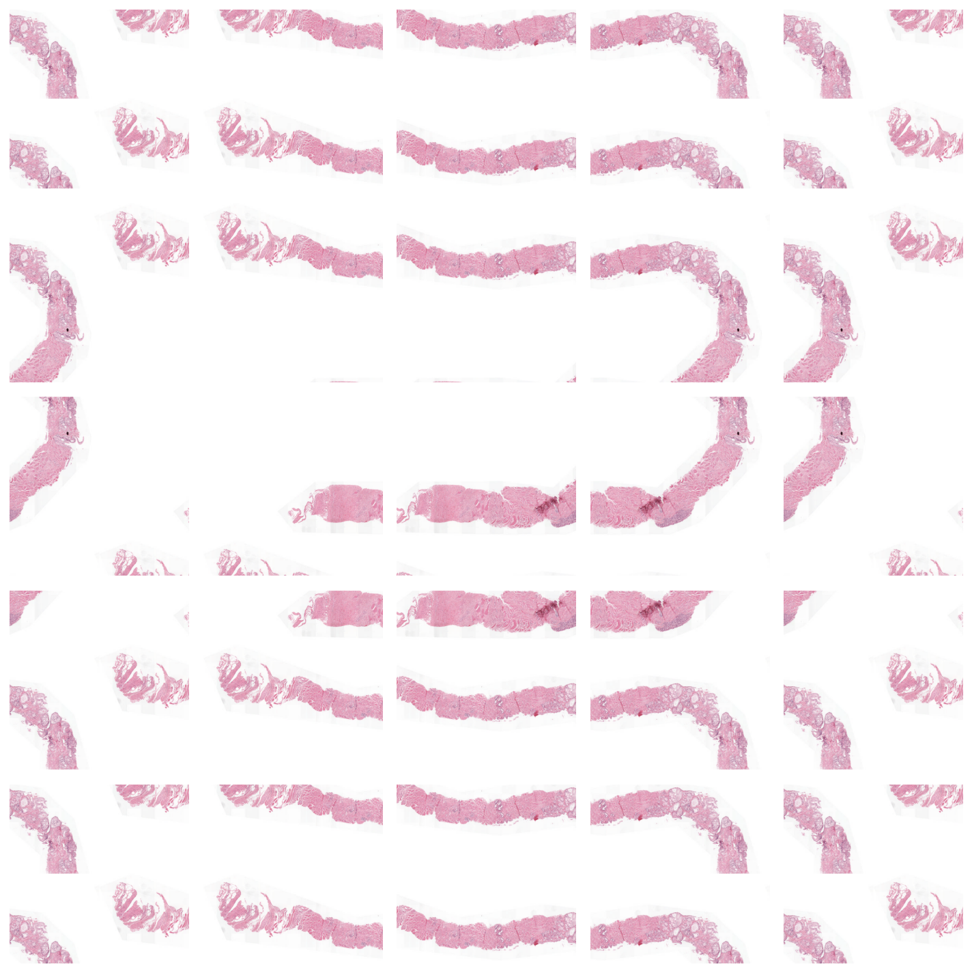
- Passing the extracted patches to the model (model output, logits):
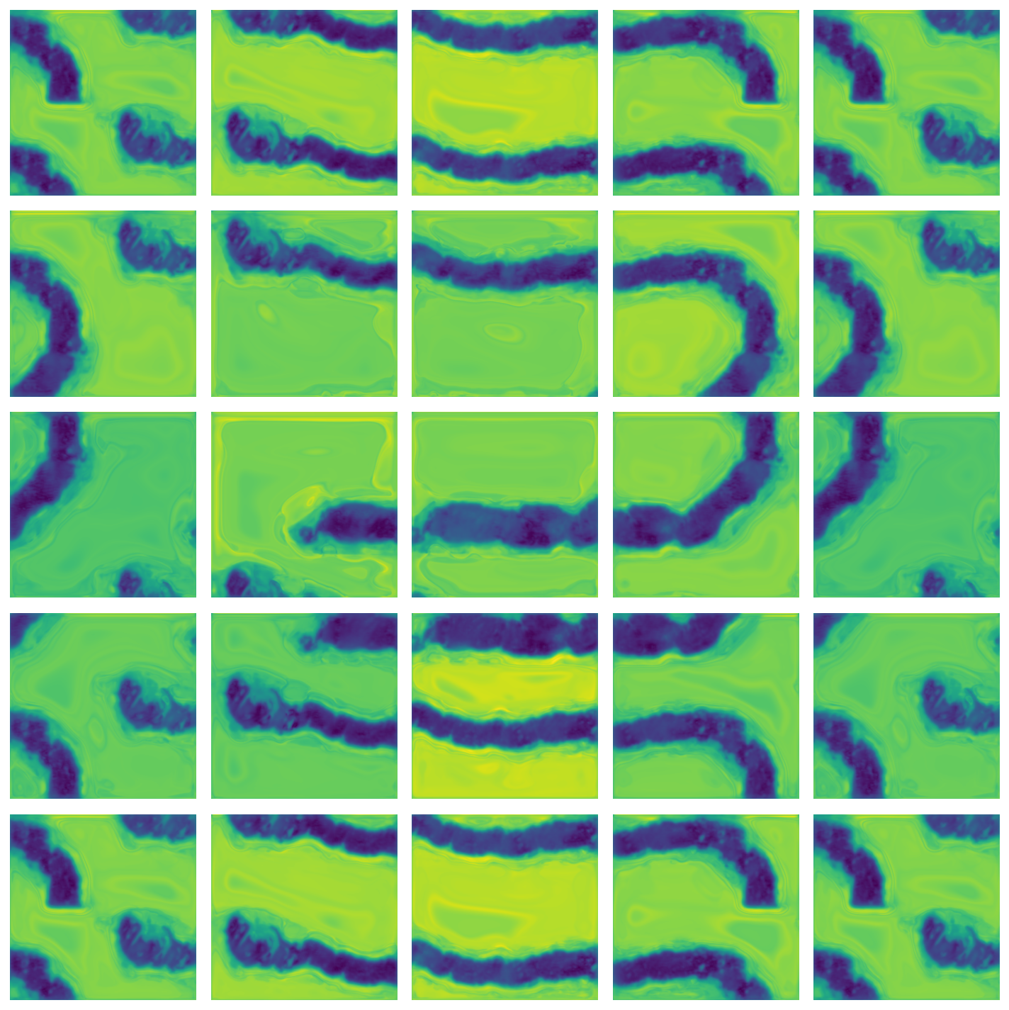
- In the next step we only crop the center of each predicted mask and stitch them back:
